**Beet Seed**

3. 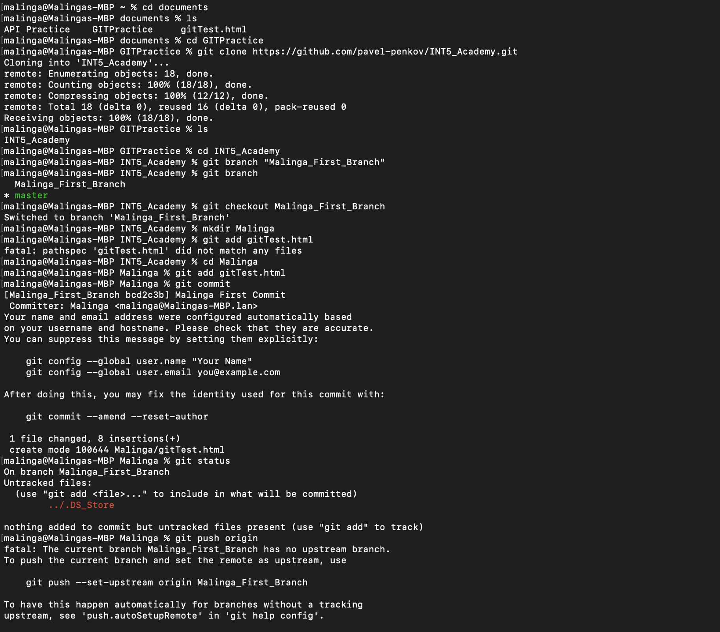

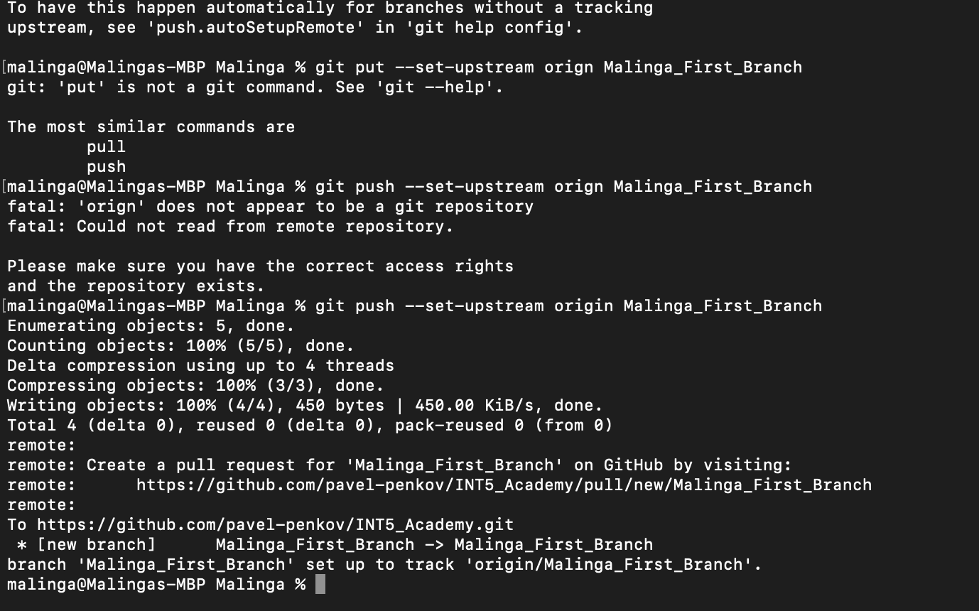

**Beet Sprout**

**Mighty Beet**